373 CHAINSTITCH BUTTON ATTACHING MACHINE

(PARTS LIST)

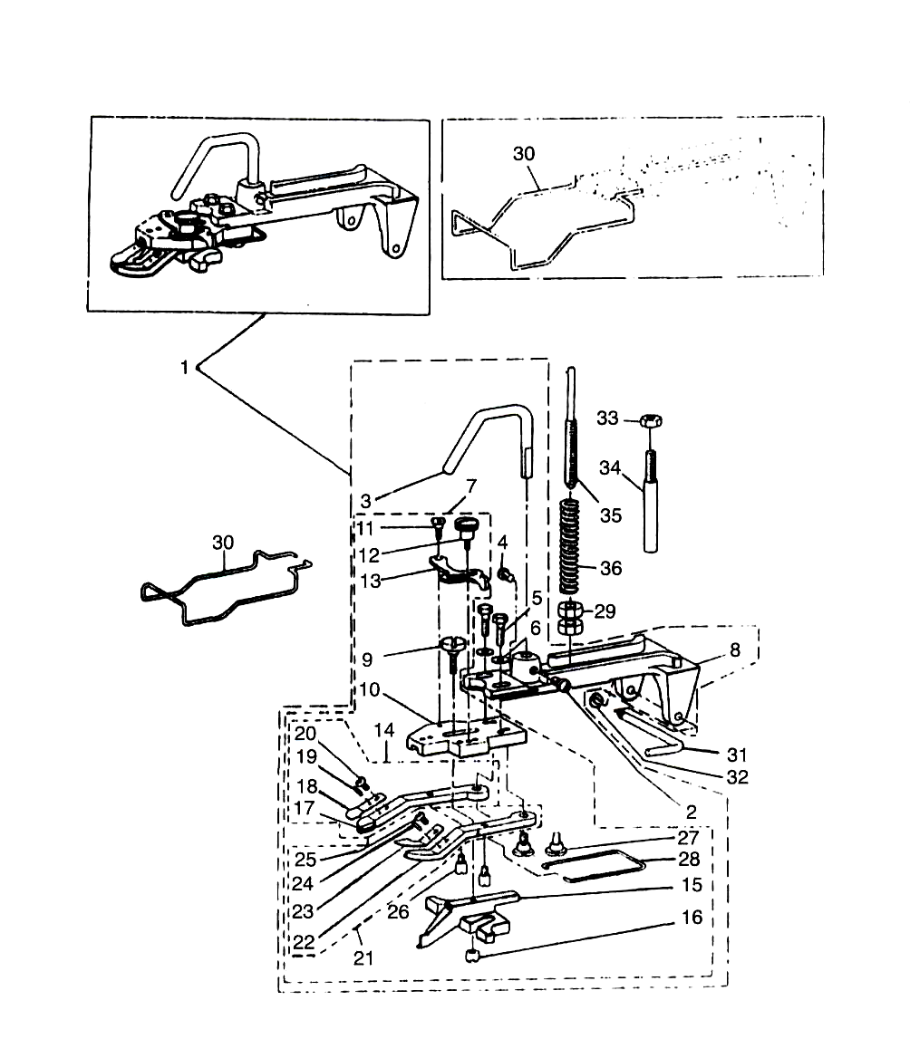
A. BUTTON CLAMP MECHANISM COMPONENTS

REF.NO. | SYMBOL | PART NO. | DESCRIPTION | Qty
1 | 10A-1 | B2547-372-0BA | FLAT BUTTON CLAMP ASM. | 1
2 | 10A-2 | SS-7150940-SP | SCREW 15/64-28X9 | 1
3 | 10A-3 | B2546-372-000 | BUTTON CLAMP LIFTING ROD | 1
4 | 10A-2 | SS-7150940-SP | SCREW 15/64-28X9 | 1
5 | 10A-5 | SS-9621413-SP | SCREW 3/16-32X13.5 | 2
6 | 10A-6 | WP-0501016-SD | WASHER 5X10.5X1 | 2
7 | 10A-7 | B2547-372-0C0 | JAW LEVER HOLDER ASM. | 1
8 | 10A-8 | B2542-372-00A | BUTTON CLAMP HOLDER | 1
9 | 10A-9 | SD-0550301-SP | HINGE SCREW D=5.5 H=3 | 1
10 | 10A-10 | B2547-372-000 | JAW LEVER HOLDER | 1
11 | 10A-11 | SD-0550181-SP | HINGE SCREW D=5.5H=1.8 | 1
12 | 10A-12 | B2549-372-000 | CLAMP SCREW A | 1
13 | 10A-13 | B2543-372-000 | SNAP FASTENER CLAMP STOP LEVER | 1
14 | 10A-14 | B2555-372-0A0 | BUTTON CLAMP LEVER JAW, LEFT A | 1
15 | 10A-15 | B2552-372-000 | BUTTON CLAMP SLIDE | 1
16 | 10A-16 | B2553-372-000 | NUT | 1
17 | 10A-17 | B2555-372-000 | BUTTON CLAMP LEVER JAW (LEFT) | 1
18 | 10A-18 | B2556-372-000 | BUTTON HOLDING SPRING, LEFT | 1
19 | 10A-19 | B2559-372-000 | BUTTON CLAMP LOCATING PIN | 1
20 | 10A-20 | SS-7090410-SP | SCREW 9/64-40X3.5 | 1
21 | 10A-21 | B2557-372-0A0 | BUTTON CLAMP LEVER JAW, RIGHT | 1
22 | 10A-22 | B2557-372-000 | BUTTON CLAMP LEVER JAW RIGHT | 1
23 | 10A-23 | B2558-372-000 | BUTTON HOLDING SPRING, RIGHT | 1
24 | 10A-19 | B2559-372-000 | BUTTON CLAMP LOCATING PIN | 1
25 | C-70 | SS-7090410-SP | SCREW 9/64-40X3.5 | 1
26 | 10A-26 | B2560-372-000 | BUTTON CLAMP STOP PIN | 2
27 | 10A-27 | SD-0640391-TP | HINGE SCREW | 2
28 | 10A-28 | B2561-372-000 | BUTTON CLAMP SPRING | 1
29 | 10A-29 | NS-6660511-SP | NUT 1/4 | 2
30 | 10A-30 | B3130-372-000-A | FINGER GUARD | 1
31 | 10A-31 | B2540-372-000 | HINGE PIN | 1
32 | 10A-32 | B2541-372-000 | SNAP RING | 1
33 | 10G-18 | NS-6150430-SP | NUT 15/64-28 | 1
34 | 10A-34 | B2543-372-000-A | BUTTON CLAMP STOPPER PIN | 1
35 | 10A-35 | B2544-372-000 | BUTTON CLAMP PRESSURE ADJUSTING | 1
36 | 10A-36 | B2545-372-000 | PRESSURE ADJUSTING SPRING | 1

В. ARM & MISCELLANEOUS COVERS COMPONENTS

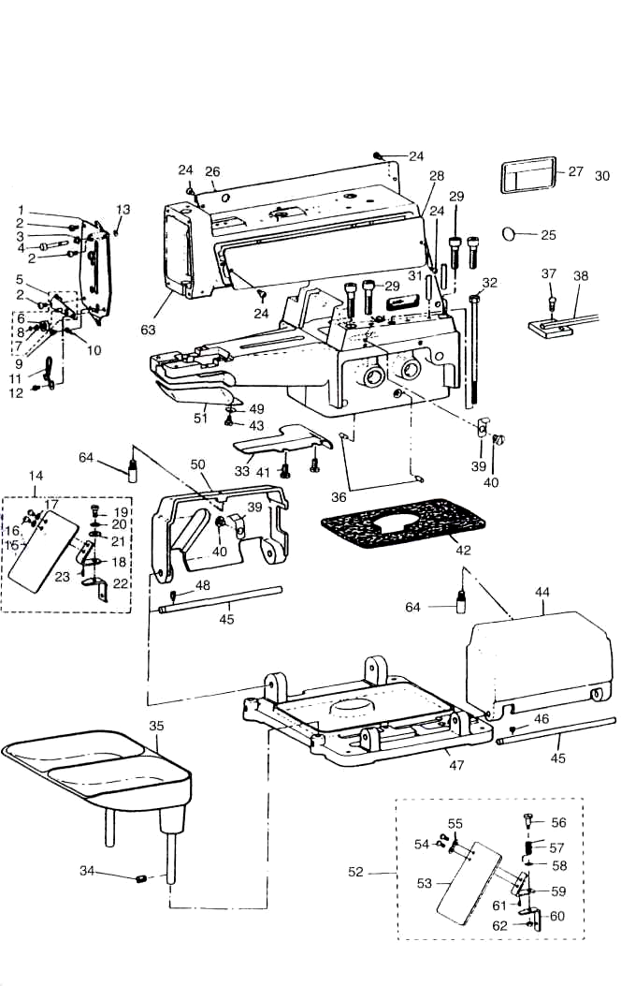

REF.NO. | SYMBOL | PART NO. | DESCRIPTION | Qty
1 | 10B-1 | В3101-372-0А0 | FRONT COVER ASM. | 1
2 | 10B-2 | SS-4120915-SP | NUT 3/16-28X9 | 3
3 | 10B-3 | В3149-123-А00 | TENSION SPRING | 1
4 | 10B-4 | В3127-372-000 | NIPPER RELEASING STUD | 1
5 | 10B-5 | 260-01164 | THREAD TENSION GUIDE NO. 3 ASM. | 1
6 | 10В-6 | 260-01404 | THREAD TENSION DISC NO. 3 | 2
7 | 10В-7 | 260-01305 | THREAD TENSION SPRING NO. 3 | 1
8 | 10А-32 | RE-0300000-K0 | E-RING3 | 1
9 | ЗА-9 | SS-7110340-SP | SCREW 11/64-40X3.2
10 | 10В-10 | В31 08-372-000 | THREAD GUIDE NO. 4
11 | 10В-1 1 | В3107-373-000 | THREAD GUIDE NO. 3
12 | 10В-2 | SS-4120915-SP | SCREW 3/16-28X9
13 | 10А-32 | RE0320000-K0 | E-RING3.2
14 |  | В3120-372-0А0 | SAFETY PLATE ASM. | 1
15 |  | В31 20-372-000 | SAFETY PLATE | 1
16 |  | SS-4110715-SP | SCREW 11/64-40X7 | 2
17 |  | WP-0450801-SD | WASHER 4.5X10X0.8 | 2
18 |  | В3121-372-000 | SAFETY PLATE INSTALLING PLATE | 1
19 |  | SD-0600401-SD | HINGE SCREW | 1
20 |  | В3125-155-000 | DISK SPRING | 1
21 |  | WP-0650876-SD | WASHER 6.5X13X0.8 | 1
22 |  | В31 22-372-000 | SAFETY PLATE MOUNTING BASE | 1
23 |  | PS-0200062-KH | SPRING PIN | 1
24 | 10В-2 | SS-4120915-SP | SCREW 3/16-28X9 | 8
25 |  | 100-04109 | GROUND MARK | 1
26 | 10В-26 | B1131-372-000 | SIDE PLATE, LEFT | 1
27 |  | CM-3002001-A1 | SAFETY LABEL.,3 (SMALL). | 1
28 | 10В-28 | B1130-372-000 | SIDE PLATE, RIGHT | 1
29 | 9Н-6 | SM-6083042-CH | SCREW M8X32 | 4
30 |  | CM-3002001-01 | SAFETY LABEL,1 (SMALL). | 1
31 | 10В-31 | В1105-372-000 | GUIDE PIN | 2
32 | 10В-32 | В1128-372-000 | SET SCREW | 1
33 | 10В-33 | В1119-373-000 | BED OIL SHIELD | 1
34 | 2В-5 | SS-8150710-SP | SCREW 15/64-28X7.5 | 1
35 | 10В-35 | 178-48458 | BUTTON TRAY ASM. | 1
36 | 10В-36 | В2504-372-000 | CAM INDICATING PIN | 2
37 | ЗС-2 | SS-7110840-SP | SCREW 11/64-40X10 | 1
38 | 10В-38 | В3503-372-0А0-А | OIL SUPPLY FELT | 1
39 | 10В-39 | В1127-372-000-А | SIDE COVER SPRING | 2
40 | С-20 | SS-7120640-SP | SCREW 9/64-40X8 | 2
41 | ЗС-2 | SS-7110840-SP | SCREW 11/64-40X10 | 2
42 | 10В-42 | В1104-372-А00 | OIL DRIP FELT (A) 5MM | 1
43 | 10В-43 | SD-0600271-SP | HINGE SCREW D=6 H=2.7 | 1
44 | 10В-44 | В1126-372-00А | SIDE COVER, RIGHT | 1
45 | 10В-45 | В1110-372-000 | SIDE COVER HINGE SHAFT | 2
46 | 2В-5 | SS-8150710-SP | SCREW 15/64-28X7 | 1
47 | 10В-47 | В1103-372-000 | MACHINE SUB-BASE | 1
48 | 2В-5 | SS-8150710-SP | SCREW 15/64-28X7 | 1
49 | 10В-49 | WS-0650389-KP | SPRING WASHER 6.5X14X17 | 1
50 | 10В-50 | В1125-372-00А | SIDE COVER, LEFT | 1
51 | 10В-51 | 260-03608 | LOOPER COVER | 1
52 | 10В-52 | В3115-372-0А0 | SAFETY PLATE ASM. | 1
53 | 10В-53 | В3120-372-000 | SAFETY PLATE | 1
54 | 10В-54 | SS-4110715-SP | SCREW 11/64-40X7 | 2
55 | 10D-49 | WP-0450801-SD | WASHER 4.5X10X0.8 | 2
56 | 10В-56 | SD-0601021-SP | HINGE SCREW | 1
57 | 10В-57 | 139-43204 | SAFETY PLATE RETURN SPRING | 1
58 | 8Е-43 | WP-0740516-SP | WASHER 6.2X9.5X1 | 1
59 | 10В-59 | В3121-372-000 | SAFETY PLATE INSTALLING PLATE | 1
60 | 10В-60 | В3115-372-000 | SAFETY PLATE INSTALLING BASE | 1
61 | 10В-61 | PS-0200062-KH | SPRING PIN | 1
62 | 2F-13 | NS-6110310-SP | NUT 11/64-40 | 1
63 | 10В-63 |  | MAINFRAME | 1
64 | 10В-64 |  | SCREW 15/64-28 | 2

С. LOOPER SHAFT MECHANISM COMPONENTS

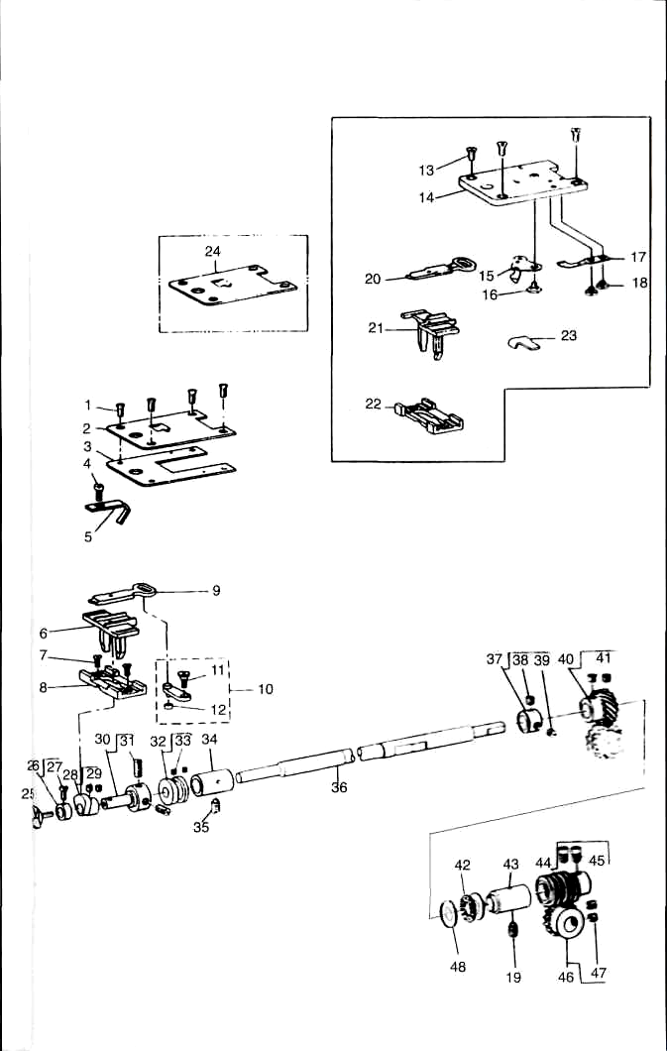

REF.NO. | SYMBOL | PART NO. | DESCRIPTION | Qty
1 |  | SS-2110920-TP | SCREW 11/64-40X8.5 | 4
2 |  | В1241-372-000 | THROAT PLATE | 1
3 |  | В1240-372-000 | SPACER PLATE | 1
4 | ЗС-2 | SS-7110840-SP | SCREW 11/64-40X7.8 | 1
5 | 10C-5 | В1242-373-000 | NEEDLE GUARD | 1
6 |  | В1236-372-000 | POSITIONING FINGER YOKE SLIDE | 1
7 | 10C-7 | SS-1110710-SP | SCREW 11/64-40X6.5 | 2
8 |  | B1235-372-000 | YOKE SLIDE INSERT | 1
9 |  | B1237-372-000 | YOKE SLIDE | 1
10 | 10C-10 | B1230-372-0A0 | LOOP POSITIONING FINGER LEVER | 1
11 | 10C-11 | SD-0640241-SP | HINGE SCREW D=6.35 H=2.4 | 1
12 | 10C-12 | B1232-372-000 | ROLL | 1
13 | 10С-13 | SS-2110920-TP | SCREW 11/64-40X8.5 | 3
14 | 10С-14 | B1241-373-000 | THROAT PLATE | 1
15 | 10С-15 | B2406-373-0A0 | MOVING KNIFE ASM. | 1
16 | 10С-16 | SD-0600095-TH | HINGE SCREW D=6 H=0.85 | 1
17 | 10С-17 | B241 0-373-000 | COUNTER KNIFE | 1
18 | 10С-18 | SS-7080310-SP | SCREW 1/8-44X3 | 2
19 | 10С-19 | SS-8151150-SP | SCREW 15/64-28X10.5 | 1
20 | 10С-20 | B1 237-373-000 | YOKE SLIDE | 1
21 | 10С-21 | B1236-373-000 | POSITIONING FINGER YOKE SLIDE | 1
22 | 10С-22 | B1235-373-000 | YOKE SLIDE INSERT | 1
23 |  | B2414-373-000 | GAUGE | 1
24 |  | B1241-372-B00 | THROAT PLATE | 1
25 | 10С-25 | B1239-372-000 | LOOPER | 1
26 | 10С-26 | CS-079072A-TH | THRUST COLLAR ASM. | 1
27 | 10С-27 | SS-7090620-TP | SCREW 9/64-40X6.1 | 1
28 | 10С-28 | B1234-372-0A0 | LOOP POSITIONING FINGER CAM ASM. | 1
29 | ЗС-14 | SS-8110410-TP | SCREW 11/64-40X3.5 | 2
30 | 10С-30 | B1233-372-0A0 | LOOPER & CAM SLEEVE | 1
31 | ЗВ-6 | SS-8150410-TP | SCREW 15/64-28X4 | 2
32 | 10С-32 | B1228-372-OA0 | LOOP POSITIONING FINGER ASM. | 1
33 | 10С-33 | SS-8110310-SP | SCREW 11/64-40X2.8 | 2
34 | 10С-34 | B1227-372-000 | LOOPER SHAFT BUSHING, FRONT | 1
35 | 10С-19 | SS-8151150-SP | SCREW 15/64-28X10.5 | 1
36 | 10С-36 | B1219-372-000 | LOOPER SHAFT | 1
37 | 10С-37 | CS-111101B-SH | THRUST COLLAR ASM. | 1
38 | 10С-39 | SS-8660512-TP | SCREW 1/4-40X5 | 1
39 | 10С-39 | SS-8660330-SP | SCREW 1/4-40X5 | 1
40 | 10С-40 | B1224-372-0A0 | LOOPER SHAFT DRIVEN GEAR ASM. | 1
41 | 10С-41 | SS-8660612-TP | SCREW 1/4-40X6 | 2
42 | 8Е-19 | B1215-372-A00 | THRUST BALL BEARING | 1
43 | 10С-43 | B1222-372-000 | LOOPER SHAFT BUSHING, REAR | 1
44 | 10С-44 | B1221-372-0A0 | DRIVEN WORM ASM. | 1
45 | 10С-45 | SS-6660712-TP | SCREW 1/4-40X7 | 2
46 | 10С-46 | B1220-372-0A0 | CAM SHAFT DRIVEN GEAR ASM. | 1
47 | 10С-41 | SS-8660612-TP | SCREW 1/4-40X6 | 2
48 | 8В-18 |  | WASHER | 2

D. NIPPER & THREAD TENSION PARTS COMPONENTS

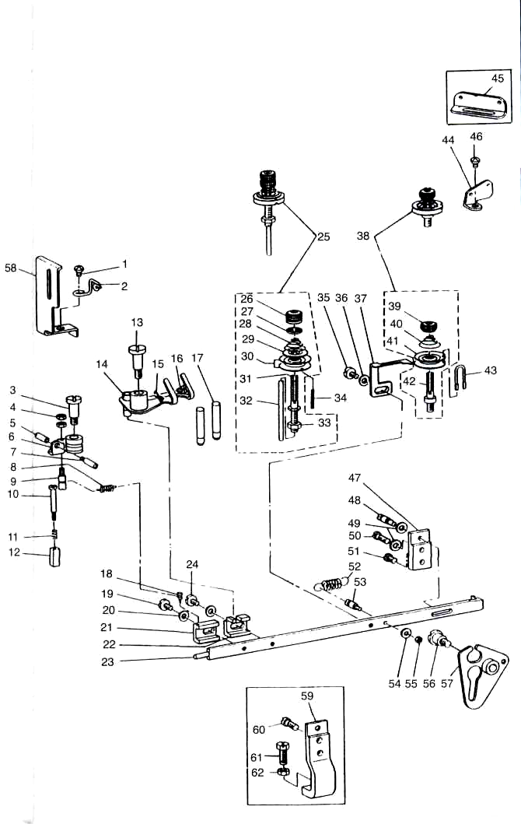

REF.NO. SYMBOL | SYMBOL | PART NO. | DESCRIPTION | Qty
1 | 10D-1 | SS-4150915-SP | SCREW 15/64-28X9 | 1
2 | 10D-2 | B2038-372-000 | THREAD GUIDE N0.2 | 1
3 | 10D-3 | SD-0791271-SP | HINGE SCREW D=7.94H=12.7 | 1
4 | 8A-29 | NS-6080210-SP | NUT 1/8-44 | 2
5 | 10D-5 | B2035-372-000 | NUT | 1
6 | 10D-6 | 260-00950 | NIPPER COMPL. | 1
7 | 10D-7 | B2034-372-000 | THREAD RELEASING SCREW STUD | 1
8 | 10D-8 | B2037-372-000 | NIPPER BAR BLOCK SPRING | 1
9 | 10D-9 | B2036-372-000 | NIPPER BAR BLOCK SPRING SCREW | 1
10 | 10D-10 | SD-0402001-TP | HINGE SCREW D=4 H=20 | 1
11 | 10D-11 | B2029-372-000 | NIPPER BLOCK SPRING | 1
12 | 10D-12 | B2028-372-000 | NIPPER BLOCK | 1
13 | 10D-13 | SD-0791501-SP | HINGE SCREW D=7.94H=15 | 1
14 | 10D-14 | B2025-372-0B0 | THREAD PULL-OFF LEVER ASM. | 1
15 | 10D-15 | B2040-373-000 | THREAD GUIDE | 1
16 | 10D-16 | SS-4090415-SP | SCREW 9/64-40X4 | 1
17 | 10D-17 | B2024-372-000-A | THREAD GUIDE PIN | 2
18 | 10D-18 | B2012-372-000 | NIPPER BAR BLOCK SPRING PIN | 1
19 | 10D-19 | SS-6120930-TP | SCREW 3/16-28X9 | 1
20 | 10A-6 | WP-0501016-SD | WASHER 5X10.5X1 | 2
21 | 10D-21 | B2011-372-000 | NIPPER BAR BLOCK | 1
22 | 10D-22 | B2010-372-000 | NIPPER BAR BLOCK REAR | 1
23 | 10D-23 | B2004-372-000 | NIPPER BAR | 1
24 | 10D-19 | SS-6120930-TP | SCREW 3/16-28X9 | 1
25 | 10D-25 | B2019-372-0A0 | TENSION POST ASM. | 1
26 | 10D-26 | B3116-125-000 | TENSION NUT | 1
27 | 10D-27 | B3120-125-000 | ROTATING STOPPER | 1
28 | 10D-28 | B3114-232-000 | THREAD TENSION SPRING | 1
29 | 10D-29 | B3132-012-000 | TENSION DISC HOLDER | 1
30 | 10D-30 | B2016-372-000 | TENSION DISC | 2
31 | 10D-31 | B2019-372-000 | TENSION POST NO. 2 | 1
32 | 10D-32 | B2020-372-000 | TENSION RELEASE PIN | 1
33 | 10D-33 | NS-6160520-SP | NUT 1/4-24 | 1
34 | 10D-34 | PS-0300162-KH | SPRING PIN 3X16 | 1
35 | 10D-19 | SS-6120930-TP | SCREW 3/16-28X9 | 1
36 | 10A-6 | WP-0501016-SD | WASHER 5X10.5X1 | 1
37 | 10D-37 | B2009-372-000 | THREAD TENSION RELEASING LEVER | 1
38 | 10D-38 | B2015-372-0A0 | THREAD TENSION ASM. (NO. 1) | 1
39 | 10D-39 | B3125-012-000 | THREAD TENSION NUT | 1
40 | 10D-40 | B2017-372-000 | TENSION SPRING NO. 1 | 1
41 | 10D-30 | B201 6-372-000 | TENSION DISC | 2
42 | 10D-42 | B2015-372-000 | THREAD TENSION STAFF NO. 1 | 1
43 | 10D-43 | B2014-372-000-A | THREAD GUIDE | 1
44 |  | B1111-232-000 | THREAD GUIDE PLATE | 1
45 | 10D-45 | B2006-372-000 | THREAD GUIDE PLATE | 1
46 | 10D-1 | SS-4150915-SP | SCREW 15/64-28X9 | 1
47 |  | B2005-372-000 | NIPPER BAR BEARING BLOCK | 1
48 | 10D-48 | B2006-372-000 | ADJUSTING SCREW | 1
49 | 10D-49 | WP-0480856-SP | WASHER 4.8X8.4X0.8 | 2
50 |  | SS-6121610-TP | SCREW 3/16-28X15.5 | 1
51 | 10D-51 | SS-6121050-SP | SCREW 3/16-28X9.5 | 1
52 | 10D-52 | B2008-372-000 | THREAD TENSION SPRING | 1
53 | 10D-53 | B2007-372-000 | NIPPER BAR SPRING SCREW | 1
54 | 10D-54 | WP-0371016-SP | WASHER 3.7X8X1 | 1
55 | 10D-55 | NS-6080340-SP | NUT 1/8-44 | 1
56 | 10D-56 | SD-0790802-SP | HINGE SCREW D=7.94 H=8 | 1
57 | 10D-57 | B2001-372-0A0 | NIPPER BAR ACTUATING LEVER ASM. | 1
58 | 10D-58 | B1421 -372-000 | NIPPER BAR GUARD | 1
59 | 10D-59 | B2005-373-000-A | NIPPER BAR BEARING BLOCK | 1
60 | 3F-20 | SS-6121610-TP | SCREW 3/16-28X15.5 | 1
61 | 3G-3 |  | SCREW 15/64-28X1 1 | 1
62 | 10G-18 |  | NUT 15/64-28 | 1

E FEED PLATE COMPONENTS

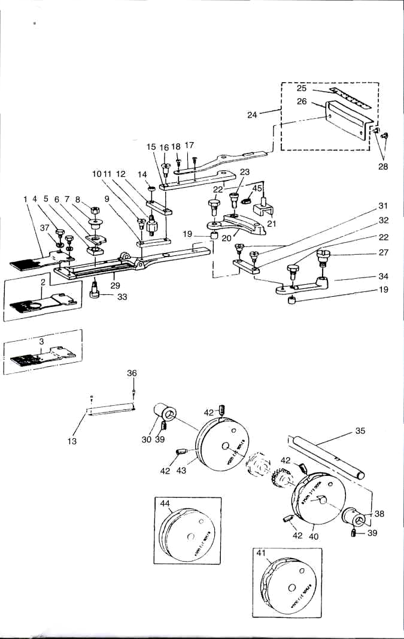

REF.NO. | SYMBOL | PART NO. | DESCRIPTION | Qty
1 |  | B2529-372-000 | FEED PLATE, SMALL BUTTON | 1
2 | 10E-2 | B2529-373-000 | FEED PLATE, SMALL BUTTON | 1
3 |  | B2529-372-C00 | FEED PLATE, SMALL BUTTON | 1
4 | 10E-4 | SS-9120643-TP | SCREW 3/16-28X6 | 2
5 | 10E-5 | B2524-372-000 | INDICATOR PIN BEARING BLOCK | 1
6 | 10E-6 | B2525-373-N00 | CROSSWISE FEED INDICATOR | 1
7 | 10E-7 | B2526-372-000 | CROSSWISE FEED INDICATOR PIN | 1
8 | 10D-33 | NS-6160520-SP | NUT 1/4-24 | 1
9 | 10E-9 | B2518-372-000-A | SLIDE PLATE CONNECTING LINK A | 1
10 | 10E-10 | SD-0640481-SP | HINGE SCREW D=6.35 H=4.8 | 1
11 | 10E-11 | B2521-372-000 | STUD | 1
12 | 10E-12 | B251 9-372-000 | INTERMEDI CONNECTING LINK | 1
13 | 10E-13 | B2528-372-000-A | CROSSWISE FEED GRADVATED PLATE | 1
14 | 10E-14 | NS-6120630-SP | NUT 3/16-28 | 1
15 | 10E-15 | B251 3-372-000 | INDICATOR SPRING CONNECTING LI | 1
16 | 10E-16 | SD-0640961-SP | HINGE SCREW D=6.35 H=9.6 | 1
17 | 10E-17 | B251 5-372-000 | HANDLE & INDICATOR SPRING | 1
18 | 4D-37 | SS-4090615-SP | SCREW 9/64-40X6 | 2
19 | 10E-19 | B2507-372-000 | CAM ROLL | 2
20 | 10E-20 | B2511-372-0A0 | LENGTHWISE FEED LEVER ASM. | 1
21 | 10E-21 | B2512-372-000 | LENGTHWISE FEED LEVER SLIDE BL | 1
22 | 10E-22 | B2508-372-000 | CAM ROLL SCREW STUD | 2
23 | 10E-23 | B2535-372-000 | LENGTHWISE HINGE SCREW | 1
24 | 10E-24 | B2563-372-0A0 | LENGTHWISE FEED SCALE ASM. | 1
25 | 10E-25 | B2563-372-000 | LENGTHWISE FEED GRADUATE PLATE | 1
26 | 10E-26 | B2564-372-000 | PLATE BASE | 1
27 | 10E-27 | SD-0791051-SP | HINGE SCREW D=7.94H=10.5 | 1
28 | 10B-2 | SS-4120615-SP | SCREW 3/16-28X6 | 2
29 | 10E-29 | B2522-373-000-A | FEED PLATE | 1
30 | 10E-30 | B2503-372-000 | CAM SHAFT BUSHING, LEFT | 1
31 | 10E-10 | SD-0640481-SP | HINGE SCREW D=6.35 H=4.8 | 2
32 | 10E-12 | B251 9-372-000 | INTERMEDI CONNECTING LINK | 1
33 | 10E-33 | B2523-372-000 | HINGE SCREW FOR CROSSWISE FEED | 1
34 | 10E-34 | B2510-372-000-A | CROSSWISE FEED LEVER | 1
35 | 10E-35 | B2501-372-000-A | CAM SHAFT | 1
36 | 10E-36 | B1161-227-000 | RIVET | 2
37 | 10A-6 | WP-0501016-SD | WASHER 5X10.5X1 | 2
38 | 10E-38 | B2502-372-000 | CAM SHAFT BUSHING, RIGHT | 1
39 |  | SS-8151150-SP | SCREW 15/64-28X10.5 | 2
40 |  | B2505-372-000-A | CROSSWISE FEED CAM | 1
41 | 10E-41 | B2505-373-000-A | CROSSWISE FEED CAM | 1
42 | 10E-42 | SS-8681412-TP | SCREW 9/32-28X13.5 | 4
43 |  | B2506-372-000-A | LENGTHWISE FEED CAM | 1
44 | 10E-44 | B2506-373-000-A | LENGTHWISE FEED CAM | 1
45 | 10E-45 |  | SCREW | 1

F. BUTTON CLAMP LIFTER COMPONENTS

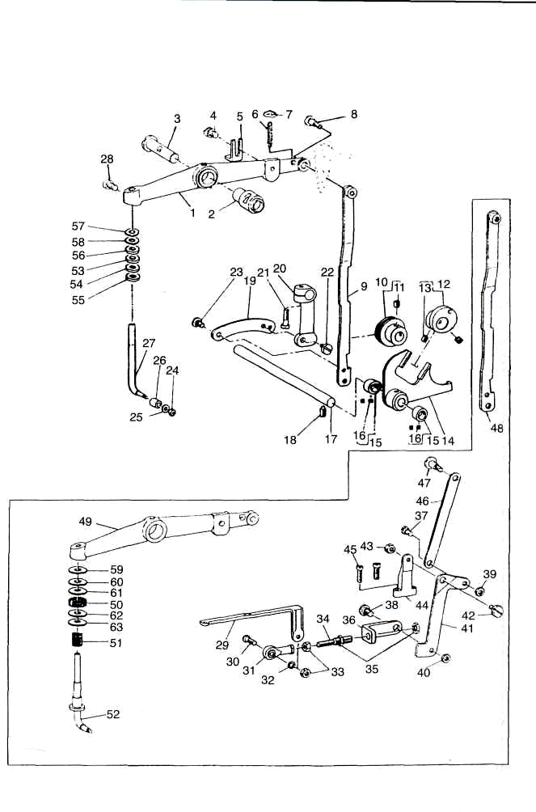

REF.NO. | SYMBOL | PART NO. | DESCRIPTION | Qty
1 |  | В4412-372-000-А | BUTTON CLAMP LIFTING LEVER | 1
2 | 10F-2 | В1407-372-000 | BUSHING | 1
3 | 10F-3 | В1408-372-000 | LIFTING LEVER SHAFT | 1
4 |  | SM-6060802-TP | SCREW M6X8 | 1
5 |  | В4415-372-000 | BUTTON CLAMP LIFTING LEVER STO | 1
6 | 10F-6 | В4419-372-000 | NIPPER BAR ACTUATING LEVER SPRING | 1
7 | 10F-7 | В4418-372-000 | WASHER | 1
8 |  | SD-0641001-SP | HINGE SCREW D=6.35H=10 | 1
9 |  | В4411-372-000-А | BUTTON CLAMP LIFTING LINK | 1
10 | 10F-10 | В4410-372-0А0 | SLIDING ROLLER ASM. | 1
11 | 10C-41 | SS-8660612-TP | SCREW 1/4-40X6 | 1
12 | 10F-12 | В4405-372-0А0 | ECCENTRIC CAM ASM. | 1
13 | 10C-41 | SS-8660612-TP | SCREW 1/4-40X6 | 2
14 | 10F-14 | В4401-372-0А0 | BUTTON CLAMP LIFTING LINK ASM. | 1
15 | 10F-15 | CS-0950810-SH | THRUST COLLAR ASM. | 2
16 | ЗС-14 | SS-8110410-TP | SCREW 11/64-40X3.5 | 4
17 | 10F-17 | В4404-372-000-А | LEVER SHAFT | 1
18 | 10С-19 | SS-8151150-SP | SCREW 15/64-28X10.5 | 1
19 | 10F-19 | В4408-372-000 | LIFTING LINK CONNECTING LINK | 1
20 | 10F-20 | В4406-372-0А0-С | LIFTING LINK LEVER ASM. | 1
21 | 10F-21 | SS-6121610-TP | SCREW 3/16-28X15.5 | 1
22 | 10Е-10 | SD-0640481-SP | HINGE SCREW D=6.35 H=4.8 | 1
23 | 10F-23 | SD-0640211-SP | HINGE SCREW D=6.35 H=2.1 | 1
24 | ЗЕ-24 | NS-6090310-SP | NUT 9/64-40 | 1
25 | 10F-25 | WP-0371026-SD | WASHER 3.7X7X1 | 1
26 | 10F-26 | В4417-372-000 | BUTTON CLAMP LIFTING ROD ROLL | 1
27 |  | В4416-372-000 | BUTTON CLAMP LIFTING ROD | 1
28 | 10F-28 | SM-6061002-TP | SCREW M6X10 | 1
29 | 10F-29 | B2404-373-R00 | CONNECTING LINK, FRONT | 1
30 | 10F-30 | В2413-373-000 | JOINT STUD | 1
31 | 10F-31 | В1632-180-000 | FEED ADJUSTING JOINT | 1
32 | 10F-32 | WP-0510516-SD | WASHER 5.1X7.5X0.5 | 1
33 | 7А-26 | NM-6050001-SP | NUT M5 | 2
34 | 10F-34 | В2412-373-000 | CONNECTING SCREW | 1
35 | 2D-15 | NS-6680410-SP | NUT 9/32-28 | 2
36 | 10F-36 | В2403-373-000-А | CONNECTING LINK, REAR | 1
37 | 10F-37 | SD-0640323-TP | HINGE SCREW D=6.35 H=3.2 | 1
38 | 10F-38 | SD-0790402-TP | HINGE SCREW D=7.94H=4 | 1
39 | 8А-16 | NS-6620310-SP | NUT 3/16-32 | 1
40 | 10G-18 | NS-6150310-SP | NUT 15/64-28 | 1
41 | 10F-41 | В2402-373-000-А | THREAD TRIMMING LEVER | 1
42 | 10F-42 | SD-0790311-TP | HINGE SCREW D=7.94H=3.1 | 1
43 | 3F-14 | NS-6110420-SP | NUT 11/64-40 | 1
44 | 10F-44 | В2405-373-000 | THREAD TRIMMING LEVER BASE | 1
45 | 2В-21 | SS-7111410-TP | SCREW 11/64-40X14 | 2
46 | 10F-46 | В2401-373-000 | THREAD TRIMMING LINK | 1
47 | 10F-47 | SD-0641322-TP | HINGE SCREW D=6.35H=13.2 | 1
48 | 10F-48 | В4411-373-000 | BUTTON CLAMP LIFTING LINK | 1
49 | 10F-49 | В4412-373-000-А | LIFTING LEVER | 1
50 | 10F-50 | В4420-373-000 | CUSHION | I
51 | 10F-51 | D9219-555-B00 | SAFETY MAGNET | 1
52 | 10F-52 | В4416-373-АА0 | BUTTON CLAMP LIFTING ROD ASM. | 1
53 |  | WP-0704516-SP | WASHER 7X20X4.5 | 1
54 |  | WP-0703516-SP | WASHER 7X20X3.5 | 1
55 |  | WP-0704016-SP | WASHER 7X20X4 | 1
56 |  | В4420-373-000 | CUSHION | 1
57 |  | WP-0751576-SD | WASHER 7.5X19X1.5 | 2
58 |  | WP-0851846-SC | WASHER 8.5X22X1.8 | 2
59 |  | WP-0704516-SP | WASHER 7X20X4.5 | 1
60 | 10F-60 | WP-0703516-SP | WASHER 7.5X20X1.8 | 1
61 |  | WP-0704016-SP | WASHER 7X20X4 | 1
62 | 10F-60 | WP-0751576-SD | WASHER 7.5X20X1.8 | 2
63 | 10F-60 | WP-0851846-SC | WASHER 7.5X20X1.8 | 1

G. NEEDLE DRIVING PULLEY SHAFT COMPONENTS

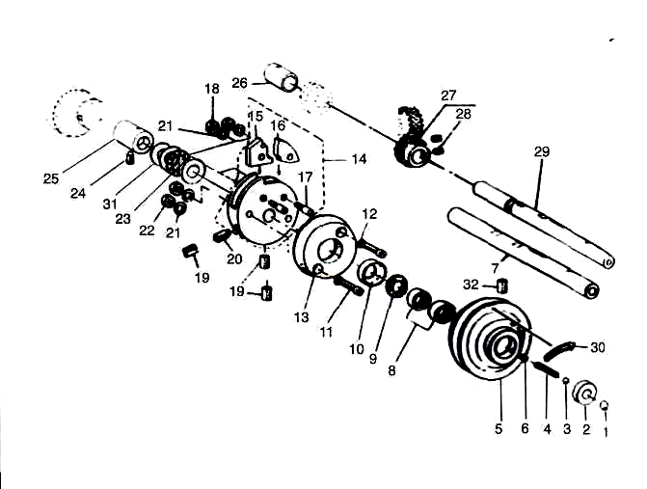

REF.NO | SYMBOL | PART NO. | DESCRIPTION | Qty
1 | 10G-1 | B1203-372-000 | BALL LARGE | 1
2 | 10G-2 | B1204-372-000 | PULLEY INSERT | 1
3 | 10G-3 | В1246-372-000 | BALL SMALL | 1
4 | 10G-4 | В1205-372-000 | SPRING | 1
5 | 10G-5 | В1202-372-000 | NEEDLE DRIVING PULLEY | 1
6 | 8B-20 |  | SCREW 7/32-32X6.5 | 1
7 | 10G-7 | В1201-373-000 | NEEDLE DRIVING PULLEY SHAFT | 1
8 | 8E-35 | В1243-372-000 | NEEDLE BEARING | 2
9 | 10G-9 | В1206-372-000 | GREASE RETAINING WICK | 1
10 | 8E-33 | В1207-372-000 | RETAINING WASHER | 1
11 | 8E-30 | SS-6152440-SP | SCREW 15/64-28X23.5 | 2
12 | 8E-43 | WP-0621026-SP | WASHER 6.2X9.5X1 | 2
13 | 8E-29 | В1208-372-000 | NEEDLE DRIVING PULLEY CLUTCH D | 1
14 | 8E-24 | В1210-372-0А0 | STOP MOTION DISC ASM. | 1
15 | 10G-15 | В1211-372-000 | STOP MOTION DISC PAWL (A) | 1
16 | 10G-16 | В1212-372-000 | STOP MOTION DISC LATCH (B) | 1
17 | 8E-27 | В1213-372-000 | SCREW | 2
18 | 10G-18 | NS-6150430-SP | NUT 15/64-28 | 2
19 | 10G-19 | SS-8701042-TP | SCREW 5/16-24X10 | 3
20 | 10G-20 | SS-8701782-TP | SCREW 5/16-24X17 | 1
21 | 8E-22 | WS-0651310-KP | SPRING WASHER 6.5X11X1.3 | 4
22 | 10G-18 | NS-6150430-SP | NUT 15/64-28 | 2
23 | 8E-19 |  | THRUST BALL BEARING | 1
24 | 10C-19 | SS-8151150-SP | SCREW 15/64-28X10.5 | 1
25 | 10G-25 | В1216-372-000 | PULLEY SHAFT BUSHING, RIGHT | 1
26 | 10G-26 | В1223-372-000 | PULLEY SHAFT BUSHING, LEFT | 1
27 | 10G-27 | В1217-372-0А0 | DRIVING GEAR ASM. | 1
28 | 10C-41 | SS-8660612-TP | SCREW 1/4-40X6 | 2
29 |  | В1201-372-000 | NEEDLE DRIVING PULLEY SHAFT | 1
30 | 10G-30 | СМ-5002000-01 | DIRECTION LABEL. | 1
31 | 10G-31 |  | WASHER | 3
32 | 8E-37 |  | SCREW 9/32-32X32 | 1

H. NEEDLE BAR DRIVING MECHANISM COMPONENTS

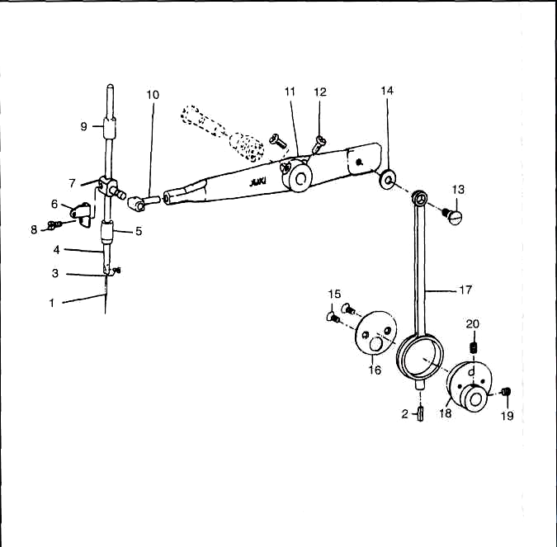

REF.NO. | SYMBOL | PART NO. | DESCRIPTION | Qty
1 | 10H-1 | MTQ-700B1600 | NEEDLE | 1
2 | 10H-2 | B3541-012-000 | OIL WICK | 2
3 | 10H-3 | SS-7080510-TP | SCREW 1/8-44X4.5 | 1
4 | 10H-4 | B1401-372-000-A | NEEDLE BAR | 1
5 | 10H-5 | B1403-372-000-A | NEEDLE BAR BUSHING, LOWER | 1
6 | 10H-6 | B3112-372-000 | NEEDLE BAR BALANCE | 1
7 | 10H-7 |  | NEEDLE BAR CLAMP | 1
8 | 10H-8 | SS-6091210-TP | SCREW 9/64-40X12 | 1
9 | 10H-9 | B1402-372-000 | NEEDLE BAR BUSHING, UPPER | 1
10 | 10H-10 |  | NEEDLE BAR BEARING BLOCK | 1
11 | 10H-1 1 | B1409-372-000-B | NEEDLE BAR ROCKING PIPE | 1
12 | 10H-12 |  | SCREW 15/64-28X11 | 2
13 | 10H-13 | SD-0950806-SH | HINGE SCREW D=9.53 H=8 | 1
14 | 10H-14 | B1425-372-000 | WASHER | 1
15 | 10C-13 | SS-2110920-TP | SCREW 11/64-40X8.5 | 2
16 | 10H-16 | B1423-372-000 | THRUST HOLDER | 1
17 | 10H-17 | B1424-372-000 | CRANK ROD | 1
18 | 10H-18 | B1422-372-000 | ECCENTRIC CAM | 1
19 | 10C-41 | SS-8660612-TP | SCREW 1/4-40X6 | 1
20 | 10H-20 | SS-8660942-TP | SCREW 1/4-40X8.5 | 1

I. STOP MOTION MECHANISM COMPONENTS

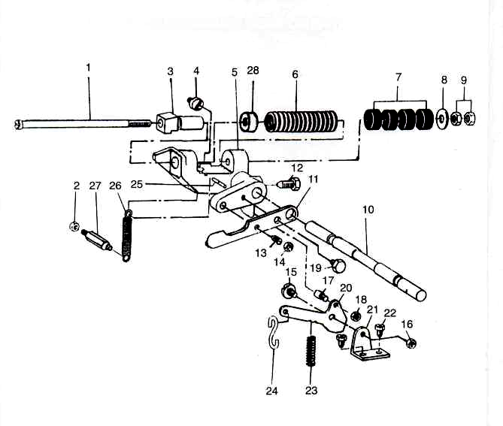

REF.NO. | SYMBOL | PART NO. | DESCRIPTION | Qty
1 | 10 I-1 | B2605-372-000 | STOP MOTION PLUNGER ROD | 1
2 | 10G-18 | NS-6150310-SP | NUT 15/64-28 | 1
3 | 10 I-3 | B2604-372-000 | STOP MOTION PLUNGER | 1
4 | 10 I-4 | SS-6151040-SP | SCREW 15/64-28X10 | 1
5 | 10 I-5 | B2602-372-000-A | STOP MOTION PLUNGER LEVER | 1
6 | 8D-7 |  | STOP MOTION SPRING | 1
7 | 8D-5 |  | RUBBER CUSHION | 6
8 | 8D-4 | B8220-804-000 | WASHER | 1
9 | 8D-2 | NS-6680410-SP | NUT 9/32-28 | 2
10 | 10 I-10 | B2601-373-N00-A | STOP MOTION LEVER SHAFT | 1
11 | 10 I-11 | B2611-372-000 | STOP MOTION DISC PRESSURE LEVER | 1
12 | 10 I-12 | B2603-372-000 | SCREW | 1
13 | 10 I-13 | SS-8151570-SP | SCREW 15/64-28X15 | 1
14 | 10G-18 | NS-6150310-SP | NUT 15/64-28 | 1
15 | 10 I-15 | SD-0680271-SP | HINGE SCREW D=6.8 H=2.7 | 1
16 | 10G-18 | NS-6150310-SP | NUT 15/64-28 | 1
17 | 10 I-17 | B2615-372-000 | STOP SCREW | 1
18 | 10G-18 | NS-6150310-SP | NUT 15/64-28 | 1
19 | 3G-3 |  | SCREW 15/64-28X11 | 1
20 | 10 I -20 | B2614-372-000 | STOP MOTION TRIP LEVER | 1
21 | 10 I-21 | B2612-372-000 | STOP MOTION TRIP LEVER BRACKET | 1
22 | 2 I-19 | SS-9150860-SP | SCREW 15/64-28X8 | 2
23 | 10 I -23 | B2616-372-000 | SPRING | 1
24 | 8G-53 | B8133-019-000 | S SHAPED HOOK | 1
25 | 8D-18 | B2608-372-000 | STOP MOTION LEVER SPRING PIN | 1
26 | 8D-15 | B2609-372-000 | STOP MOTION LEVER SPRING | 1
27 | 10 I -27 | B2610-372-000 | SCREW STUD | 1
28 |  |  | WASHER | 1

J. STITCH SELECTING PARTS COMPONENTS

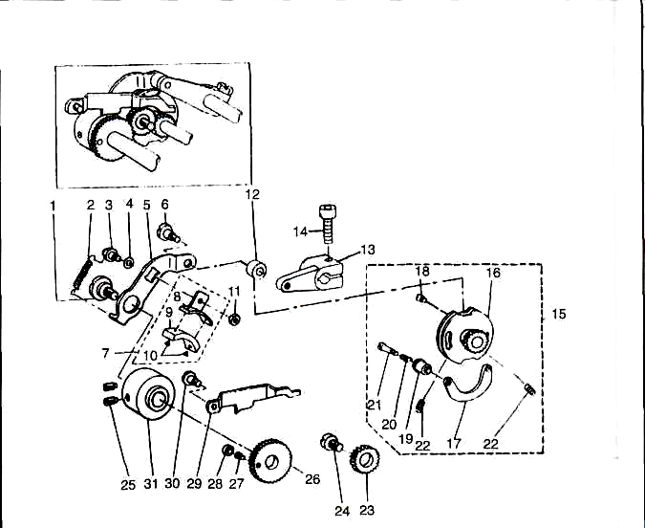

REF.NO. | SYMBOL | PART NO. | DESCRIPTION | Qty
1 | 10J-1 | SD-1127321-SP | HINGE SCREW D=12.7H=3.2 | 1
2 | 10J-2 | B2643-372-000 | SPRING FOR FRICTION PLATE | 1
3 | 10J-3 | B2638-372-000-A | FRICTION PLATE ROTATING SHAFT | 1
4 | 10J-4 | WP-0850002-SP | WASHER 8.4X16X1.6 | 1
5 | 10J-5 | B2636-372-000-A | SPEED SLOWING LEVER | 1
6 | 10J-6 | SD-0791331-SP | HINGE SCREW D=7.94H=13.3 | 1
7 | 10J-7 | B2639-372-0A0 | FRICTION PLATE HOLDER ASM. | 1
8 | 10J-8 | B2639-372-000 | FRICTION PLATE HOLDER | 1
9 | 10J-9 | B2640-372-000 | SPEED SLOWING FRICTION PLATE | 1
10 | 10J-10 | B3211-232-000 | POSITIONING PIN | 2
11 | 3F-14 | NS-6110310-SP | NUT 11/64-40 | 1
12 | 10J-12 | B2619-372-000 | STOP MOTION TRIPPING LEVER CAM | 1
13 | 10J-13 |  | STOP MOTION TRIPPING LEVER ASM. | 1
14 | 10J-14 | SM-6082502-TP | SCREW M8X25 | 1
15 | 10J-15 | B2621-372-0B0 | STOP MOTION CAM ASM. | 1
16 | 10J-16 | B2621-372-0A0 | STOP MOTION CAM ASM. | 1
17 | 10J-17 | B2623-372-000 | STOP MOTION CAM SHOE | 1
18 | 10J-18 | B2624-372-000 | SCREW FOR STOP MOTION CAM SHOE | 1
19 | 10J-19 | B2625-372-000 | STOP MOTION CAM KNOB | 1
20 | 10J-20 | B2626-372-000 | SPRING | 1
21 | 10J-21 | SD-0481451-SP | HINGE SCREW D=4.8H=14.5 | 1
22 | 10J-22 | SS-8150912-TH | SCREW 15/64-28X9 | 2
23 | 10J-23 | B2629-372-000 | STITCH SELECTING SPUR GEAR, MI | 1
24 | 10J-24 | B2628-372-000-A | INTERMEDIATE GEAR SHAFT | 1
25 | 10C-19 | SS-8151150-TP | SCREW 15/64-28X10.5 | 2
26 | 10J-26 | B2630-372-000-A | GEAR, LARGE | 1
27 | 10J-27 | B2631-372-000 | SCREW | 1
28 | 10J-28 | B2632-372-000-A | ROLL | 1
29 | 10J-29 | B2642-372-000 | STITCH ADJUSTING LEVER | 1
30 | 10J-30 | SD-0600361-SP | HINGE SCREW D=6 H=3.6 | 1
31 | 10J-31 | B2635-372-000-A | SPEED SLOWING FRICTION WHEEL | 1

К. THREAD STAND COMPONENTS

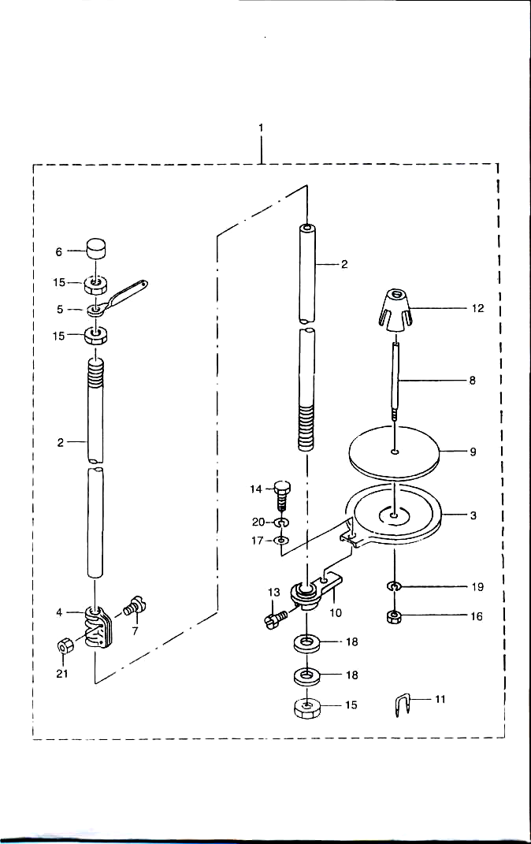

REF.NO. SYMBOL | PART NO. | DESCRIPTION | Qty
1 | B3301-180-0AA | THREAD STAND ASM. | 1
2 | 111-85105 | SPOOL REST ROD, LOWER | 2
3 | B3303-180-000 | SPOOL REST | 1
4 | B3305-704-000-A | SPOOL REST ROD JOINT | 1
5 | B3307-704-000 | THREAD GUIDE A | 1
6 | B3311-704-000 | SPOOL REST ROD CAP | 1
7 | SM-4051405-SE | SCREW M5X14 | 2
8 | B3320-704-L00-A | SPOOL PIN | 1
9 | B3311-012-000 | SPOOL REST CUSHION | 1
10 | D3302-772-T00 | SPOOL REST BRACKET | 1
11 | MA0-11532000 | CORD STAPLE | 3
12 | 111-85501 | SPOOL RETAINER | 1
13 | SM-9061080-SE | SCREW M6X10 | 1
14 | SM-9050813-SE | SCREW M5-0.8X8 | 1
15 | B3317-704-000 | NUT | 3
16 | NM-6050001-SE | NUT M5 | 1
17 | WP-0520656-SA | WASHER 5.2X9.5X0.6 | 1
18 | WP-1612616-SE | WASHER 16X30X2.6 | 2
19 | WS-0510002-KN | SPRING WASHER | 1
20 | WS-0521010-KN | SPRING WASHER 5.2X8.2X1 | 1
21 | NM-6050001-SE | NUT M5 | 2

L. SUBCLASS COMPONENTS FOR MODEL 372
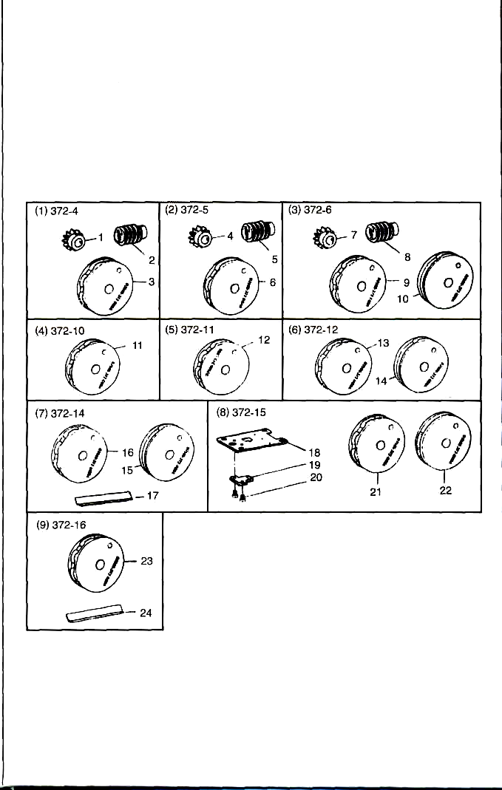

REC.NO. SYMBOL | PART NO. | DESCRIPTION | Qty
1 | D1220-372-D00 | CAM SHAFT DRIVEN GEAR, 6 STITCHES | 1
2 | D1221-372-D00 | DRIVEN WORM GEAR FOR 6 STITCHES | 1
3 | D2505-372-D00-A | CROSSWISE FEED CAM, 6 STITCHES | 1
4 | D1220-372-D00 | CAM SHAFT DRIVEN GEAR, 6 STITCHES | 1
5 | D1221-372-D00 | DRIVEN WORM GEAR FOR 6 STITCHES | 1
6 | D2505-372-D0A-A | CROSSWISE FEED CAM, Z-SHAPE | 1
7 | D1220-372-D00 | CAM SHAFT DRIVEN GEAR, 6 STITCHES | 1
8 | D1221-372-D00 | DRIVEN WORM GEAR FOR 6 STITCHES | 1
9 | D2506-372-F00-A | LENGTHWISE FEED CAM | 1
10 | D2506-372-000-A | LENGTHWISE FEED CAM | 1
11 | D2505-372-C00-A | CROSSWISE FEED CAM | 1
12 | D2506-372-L00-A | LENGTHWISE FEED CAM FOR X-SHAPE | 1
13 | D2506-372-M00-A | LENGTHWISE FEED CAM | 1
14 | D2506-372-000-A | LENGTHWISE FEED CAM | 1
15 | D2505-372-P00-A | CROSSWISE FEED CAM | 1
16 | D2506-372-M00-A | LENGTHWISE FEED CAM | 1
17 | D2528-372-P00-A | CROSS FEED SCALE | 1
18 | D1241-372-Q00 | THROAT PLATE | 1
19 | D1250-372-Q00 | NEEDLE HOLE GUIDE | 1
20 | SS-7110510-SP | SCREW 11/64-40X5 | 2
21 | D2505-372-Q00-A | CROSSWISE FEED CAM | 1
22 | D2506-372-Q00-A | LENGTHWISE FEED CAM | 1
23 | D2505-372-R00-A | CROSSWISE FEED CAM | 1
24 | D2528-372-R00-A | CROSS FEED SCALE | 1
NOTE:
This manual has been comprised on the basis of available information. Changes in design and/or improvements may incorporate a slight modification of configuration in illustrations or part umbers.

